**Project Management Plan**

Workforce

Research

Guide

**Team: Group2**

Shin Yi Lin

Fenil Shah

Ramprasadh Srivathsa

Harshal Pawar

Mark Dwight

SE 6387.001

**TABLE OF CONTENTS**

1. Introduction

1.1 Introduction, purpose and scope of the plan……………………………………………………………3

1.2 Brief overview of the product…………………………………………………………………………………..3

1.3 Description of the structure of the plan…………………………………………………………………...3

2. Project organization ……………………………………………………………………………………………………………...4

3. Lifecycle Model Used……………………………………………………………………………………………………………..5

4. Risk Analysis…………………………………………………………………………………………………………………………..5

5. Hardware and Software Resource Requirements…………………………………………………………………..6

6. Deliverables and Schedules……………………………………………………………………………………………………6

7. Monitoring, Reporting and Controlling Mechanisms……………………………………………………………..7

8. Professional Standards…………………………………………………………………………………………………………..7

9. Evidence the document has been placed under configuration management…………………………7

10. References…………………………………………………………………………………………………………………………..8

**LIST OF FIGURES**

Figure 1: Image used by Boehm to illustrate his ‘Spiral Model’ for Software Development……….5

**LIST OF TABLES**

Table 1: Project responsibilities and human resource plan…………………….………………….………………4

Table 2: Deliverables and their schedule……………………………………………………………………………………6

**1. INTRODUCTION**

**1.1 Introduction, purpose and scope of the plan**

This is the Software Project Management Plan (SPMP) of Workforce Research Guide for Alliance Data. This document describes a clear understanding of the project boundaries, with main contributions structured as deliverables. Furthermore, the organizational aspects of the project are presented, which includes the software development process employed, roles and responsibilities, methods, tools, and techniques. Finally, the management aspect of the project is presented.

**1.2 Brief overview of the product**

The team will develop Workforce Research Guide for Alliance Data. The purpose of this product is to help the management to easily organize and correlate the beliefs. The HR department of every organization occasionally needs to study their internal data and derive conclusions about the organization environment. The reason behind this can be anything like employee growth rate, employee turnover rate, financial matters, etc. So they need to correlate reports and other information generated by the various department systems and derive an overall conclusion. They can use this research information to improve the working of the organization.

The HR representatives and other management people have some beliefs/ assumptions which might be based on some information. However, it doesn’t blatantly imply that these beliefs are facts. So they generate and go through various reports and at the end of the day come up with concrete facts. These facts proves/disproves the previously held beliefs. Producing these facts is a time-consuming task and currently, there is no good solution to keep track of all such research information. So Workforce Research Guide will provide means to organize the beliefs and facts and also supporting information. The management will be able to add new beliefs as they encounter and after thorough research they can store the analyzed facts into the system with respect to the beliefs and relate the supporting documents.

So in future, if a new employee has some belief then first they can go through the existing information and see if it was recently researched by someone. This can save huge amount of resources in terms of employee time by reducing the rework.

**1.3 Description of structure of the plan**

This plan document is divided into various sections. It talks about the team structure/organization, the SDLC model being used. The plan also enlists the risks that we foresee while developing and after development and deployment of this project. We even discuss here the risk mitigation strategies. The plan also describes about the deliverables; their intended delivery method and the frequency. There are certain controlling mechanisms which we would be using in the course of this project, the same are also listed in the plan. It also gives insight into the professional work ethics that we intend to follow. At last there is a section for references used.

**2. PROJECT ORGANIZATION**

 The team roles are divided into Project Manager, System Analyst, Software Engineer, Function Developer, UI Developer and Test Engineer:

1. Project Manager: communicates with customers, monitors the schedule and working process, coordinates between each team member, and solves the problems between them.
2. System Analyst: analyzes the hardware and software parts of the system needed. Hardware part involves HR system, financial system, and external third party system. Excel format of report should be imported from these systems into the developed software. Software part involves using Java programming language in Eclipse, UML design tool for clarifying developed goal, etc.
3. Software Engineer: finds the customer’s requirement, designs the software architecture concerning about functional and nonfunctional requirement.
4. Function Developer: develops the logic functionality of the software and do the unit testing.
5. User Interface Developer develops the easy-to-use and pretty interfaces, connects interfaces and the logic functionality, and performs unit testing.
6. Test Engineer does the integration testing.

Below we list each team member’s primary responsibility with regards to the general organization of the project. We note, however, that each member is free to assist with the other project portions as needed, so effectively each member will be actively contributing to all portions of the project.

|  |  |  |
| --- | --- | --- |
| Name | Primary Responsibilities | Contact Information |
| Harshal Pawar | Software Engineer | hvp130230@utdallas.edu |
| Shin-Yi Lin | Function Developer | sxl148530@utdallas.edu |
| Mark Dwight | UI Developer | mhd100020@utdallas.edu |
| Fenil Shah | Project Manager, System Analyst | fxs140830@utdallas.edu |
| Ramprasadh Srivathsa | Test Engineer | rxs140130@utdallas.edu |

**Table 1: Project responsibilities and human resource plan.**

**3. LIFECYCLE MODEL USED**

For this project, we plan to use the spiral model. We chose this lifecycle model as it enables us to more readily gain feedback from our sponsor to facilitate the creation of the product that best fits their needs.

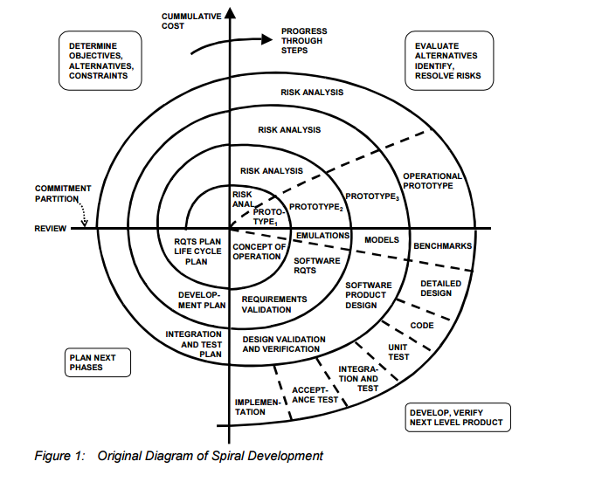

**Figure 1 Image used by Boehm to illustrate his ‘Spiral’ Model for Software Development**

**4. RISK ANALYSIS**

Risks for this project include failure of team member(s) to contribute and the inability to deliver a functioning product by the end of the semester.  The former will be dealt with in accordance to the professional standards guideline outlined in Section 8 while the latter will be handled over the course of development by adjusting expectations for the end product based on what has been completed so far and what would be feasible to complete in the time remaining.

**5. HARDWARE AND SOFTWARE RESOURCE REQUIREMENTS**

Each member will be using their own Windows computer, either desktop or laptop, during the course of development.  The product will be developed in an IDE such as NetBeans and written in an object oriented programming language such as Java or C#.  For the purposes of version control and configuration management, we will be using Github, with Google Drive being used briefly while the Github repository is being set up.

**6. DELIVERABLE SCHEDULE**

|  |  |  |
| --- | --- | --- |
| Deliverable | Due Date | Description |
| Project Management Plan | 01/29/2016 | This document describes a clear understanding of the project boundaries, with main contributions structured as deliverables. |
| Requirements Documentation | 02/12/2016 | This document describes what the product should do. It contains all the functional and nonfunctional requirements of the product. |
| Architecture Documentation | 02/26/2016 | This document describes the software architecture model that is to be used in the project. |
| Detailed Design Documentation | 03/18/2016 | This document gives a detailed description of design of the product. |
| Testing Plan | 04/08/2016 | This document outlines the test cases to be used to test the product, the traceability of said test cases to their associated use cases, and the techniques used to generate each test case. |
| Final Project Report and demonstration | 04/29/2016 | The report shall be a compilation of all the previous documents with an assessment of the goodness of the test suite. The demonstration will be a live exhibition of the end product. |

**Table 2 Deliverables and their schedule**

**7. MONITORING, REPORTING, AND CONTROLLING MECHANISMS**

The team leader will be primarily responsible for scheduling and communicating about the meetings to everyone.

We will have regular planning meeting for each of the deliverables described in the previous section. During the planning meeting we’ll identify the tasks for that deliverable and each of the team-member will take up the tasks. We will keep track of this in a shared word document internally.

To keep track of the documents as well as codebase, we will use Github as the shared repository. Everyone on the team will have the permissions to add, delete and edit all the files on the repository. Having all the permissions makes it easy to take help from teammates. If any problems arise due to this, we may change the permission policy.

We will have weekly meetings on Saturday with our sponsor to discuss the project progress and next steps. Our meeting will take place on-campus at UT Dallas Library Room, most probably in 2.540 (Lone Star Room), during 1:00 PM to 4:00 PM and it’ll be in-person meeting. We’ll also have our weekly group meeting at the same place before/after the meeting with the sponsor.

**8. PROFESSIONAL STANDARDS**

The team members are expected to perform with 100% commitment. Meetings will be held every Friday tentatively, but depending on the availability of sponsor and team members may subject to change. All team members are expected to attend the meeting regularly. In the event that they can’t do so they must inform the Project Manager/team members. We believe in quality of work and not quantity. All team members are expected to perform the assigned tasks within the timeframe and also meeting the norms set by the Professor and the team. Any disputes within the team would be first discussed within the team, if not resolved then the Professor would be contacted and evidences will be presented in front of him. Professor’s decision will be final.

**9. EVIDENCE THAT DOCUMENT HAS BEEN PLACED UNDER CONFIGURATION MANAGEMENT**

<https://github.com/WorkforceResearchGuide/WorkforceResearchGuideApp/tree/master/Deliverables>

**10. REFERENCES**

1. B. Boehm and WJ Hansen, “Spiral Development: Experience, Principles, and Refinements: Spiral Development Workshop February 9, 2000”, July 2000, <http://www.sei.cmu.edu/reports/00sr008.pdf>